## "Communication in Love and of God's Love": 4th article by Fr Gildasio Mendes in the series "St. Francis de Sales Communicator. Inner pilgrimage, wisdom in the art of communicating"

22 April 2022

[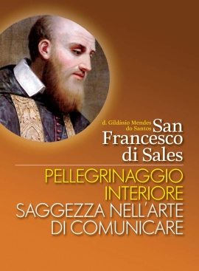](https://www.infoans.org/media/k2/items/cache/3af987fb076758c7798f6e8d12302053_XL.jpg)

**Communication in and of God’s love**

St Francis was a genuine and true communicator of the heart: “God is the God of the human heart” (Treatise on the Love of God, I, XV). His family was his first school of love. Especially with his mother, he experienced an emotional openness to love, meaning he loved and let himself be loved.

Maria Grazia Rensi has the following to say:

Francis’ first six years belonged to his mother. And it was a vigilant upbringing, but all tenderness and affection. Francis’ natural tenderness grew in childhood and adolescence, thanks to the magnificent example that his parents agreed to give him (charity). In this wholesomely human atmosphere, goodness soon sprouted in Francis’ heart.

There are various authors who go into detail about the dimension of love in Francis de Sales. I would just like to emphasise here how his mother's love gave him an inner freedom to open up to the dynamics of love in his real relationships with people, unafraid of conversing in affectionate ways, and above all having the confidence to build emotional and spiritual relationships characterised by great inner freedom and maturity.

One description of St Francis’ great love for the Song of Songs shows us something of his great sensitivity and spiritual tenderness:

By means of beautiful and tender images and comparisons drawn often from Holy Scripture (the mother breastfeeding her child, the lovers, the bride and groom), and especially from that wonderful canticle to human love which is the Song of Songs (he had followed with great interest the explanation and comments on the Song during his years of study in Paris and would never forget them).

Francis was an intense and inwardly free human being in his inner pilgrimage, especially when he experienced God as love. God creates man as a work of great love, and this fatherhood of free love creates a bond of divine sonship.

According to the Holy Doctor, man is created, structured and endowed with all that is necessary to accept God's vocation to love, to live in a relationship of love with God.

We can say that after St Augustine, it is he who opens up a theology of communication founded on the heart, in the profound relationship of the gift of love between God and the human person.

You cannot imagine the desire I feel to love more and more.

What kind of love?

It is a love of genuine human friendship that is beyond all sentimentality, a true love that comes from God, is founded in God and faithfully realises the unity of the two.

From the perspective of the Incarnation, “The Word became flesh and lived among us” (Jn 1:14), Francis believed that God had always loved his creatures.

St Francis de Sales was profoundly convinced of God's initiative in his relations with us; of the magnificence of this love and of his gratuitous and merciful nature.